[DRAFT] Improved Braking by Dynamic Control of a Single-Wheel Model
Timothy E. Coon
Florida Institute of Technology, Melbourne, FL, 32901
This paper details a progression of controller design for a quarter-car model. The goal of the controller is to stop the car in the minimum distance. In this uncontrolled scenario, the inevitable case of wheel lock-up is the result of unstable dynamics. Introducing a controller, it is shown how progressively more sophisticated control laws lead to optimal braking and shorter stopping distance.

Nomenclature
g = acceleration due to gravity
c = wheel pivot point (center)
h_{b} = s-dynamics equation of motion parameter
H = wheel-speed-dynamics equation of motion parameter
c_{i} = coefficients for friction-slip relationship
J = moment of inertia of the wheel
k_{p} = proportional gain
k_{s} = switching gain
m = mass of the vehicle
ν = inertia ratio
φ = boundary layer parameter
R = radius of the tire
s = slip variable
s_{d} = desired slip variable
T_{b} = braking-torque
u = speed of the vehicle
µ = coefficient of friction (tire-road)
ω = angular velocity of the wheel
X = tangential friction force
Y_{b} = dimensionless braking-torque
Y_{bd} = desired dimensionless braking-torque
Z = normal force on the tire from the road

Introduction
BRAKING systems for automobiles are critical and thus require designers to model dynamics with high precision. With a high-fidelity requirement and the propensity for nonlinear response, it becomes necessary for the designer to consider the task from a perspective holding within its scope the breadth of nonlinearities affecting performance. As anti-lock brake systems have become essential to meet the current industry safety standards, many effective modeling methodologies have been developed and proven. The intent of this research is to track a progression of system controller designs increasing in complexity as driven by performance needs. For simplicity, a full-scale automobile model is substituted by a quarter-car model, but without considering the influence of suspension design. Though a gross simplification, the results of simulation allow insight into the intricacies and profound effect computerized braking control has on safety.

Single-Wheel Braking Model

Equations of Motion
The single-wheel braking model used in this research is exactly as detailed by Olson in Ref. 1. Figure 1a diagrams the single-wheel model and Figure 1b equates the free-body diagram with the mass-acceleration diagram to facilitate the force- and moment-balance equations leading to the equations of motion, Equations (1).

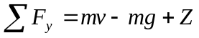
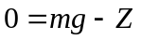
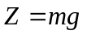

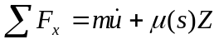
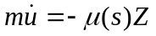
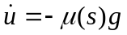
(1)

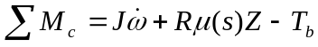
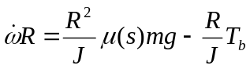
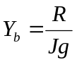; 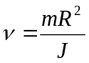
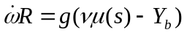
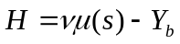
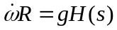

For this research, the control is accomplished by commanding the applied braking torque. The common hydraulic braking systems require control at a human-interface, the brake pedal, and require more mathematical development. Introduce tire slip parameter for braking scenario and alternate state equations (2).
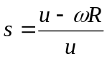
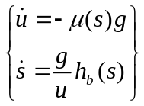
(2)
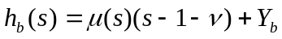

Nonlinear System Analysis

Nonlinear analysis often begins with a look at the phase portrait of a given operating point. For the braking model, only half of the phase plane is used (see Figure 2) because the range of operation is limited to 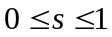 where 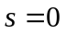is the case of free-rolling and 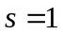is the case of wheel lock-up. In general, a constant slip value corresponds to a constant-slope line through the phase plane and is intuitive by solving for the angular velocity, 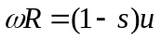.
Phase-plane analysis is often used to determine the stability of a system. For the braking system developed here, stability in the strict sense is guaranteed because the system has only the option to maintain energy or lose energy by virtue of the fact, if there is an input to the system, it is only removing energy from the system as 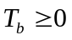. Therefore, for this analysis, stability is defined as stability of the slip dynamics in that the wheel does not not fall into a lock-up state. This action is seen in the phase portrait as those trajectory lines tending towards , equivalent to 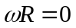.

Dynamic Control Laws
Several control laws are considered and commented on as the complexity increases.

Constant Braking-Torque

The most fundamental control scenario is one in which a constant braking-torque is applied regardless of speed or slip condition. With constant brake torque, the phases plane reveals invariant sets at particular values of 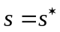and these lines of constant slope are adjusted by changing the value of constant torque applied. Using the second set of equations of motion, Eqns (2), it is possible to find the slip values yielding invariant sets by setting 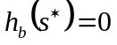and it is clear how the magnitude of the braking torque affects the location of the invariant sets. Figures 3 and 4 are phase portraits of 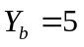 and 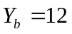, respectively. The inertia ratio remains the same throughout at 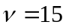.
Now, with some understanding of the influence the constant braking-torque control law has on the performance, the question of optimization may be posed. What torque value yields a minimum stopping distance? To answer this, note the braking force is limited by the coefficient of friction, 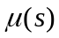, and the normal force, Z. Because, in this simple model, the normal force is always the same, the maximum attainable braking force corresponds to the maximum friction condition. Friction reaches a maximum value according to Equation (3) when 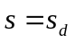 as shown in Figure 2. Therefore, the maximum braking force and minimum braking distance is achieved when a braking torque is applied to maintain the slip variable at its desired value, 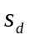, found by setting 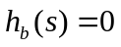 to make Equation (4). As before, a constant value of slip corresponds to an invariant s-dynamics set, a constant-slope line through the phase plane. For each of the values of 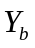used previously, there can be seen two intermediate invariant sets, one stable and one unstable. By setting , these two invariant sets reduce to one unstable set. Therefore, we are unable to brake with the desired torque, or even close to it, without running the risk of locking up the wheel. Figures 5 and 6 show the phase portrait and time simulations respectively. From these, it is clear that the initial conditions leading to wheel lock-up take considerably longer to stop than do those which maintain the optimal slip value when braking.
(3)
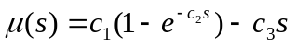
(4)
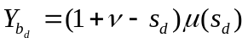

Proportional Feedback Control

Constant braking-torque control is not an accurate representation of the actual dynamics. In a real-world braking scenario, we must consider the braking-torque applied varies according to the dynamics of the hydraulic system and the angular velocity of the wheel. For this simulation, it is possible to add a dimensionless torque value equal to the wheel angular velocity multiplied by a user-defined constant proportional gain, Equation (5). This captures, to first-order, the fact more torque is applied when the wheel is spinning faster for the same hydraulic braking force. Choose the gain such that of the same order of magnitude as 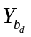 for as long as possible.
Furthermore, from the phase portrait, it can be seen there is no unstable point. The wheels do not lock up because 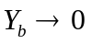as 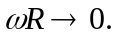 Figures 8 and 9 show the phase portrait and time response, respectively.
(5)
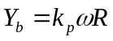

Proportional-only feedback is subject to the limitation whereby, though it quickly approaches the desired state to start, the effort reduces with proximity and reaching time is increased. The controller can be enhanced by adding integral control, and changing the control law to use 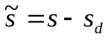.

Switching Control

Switching control is a straightforward means of applying nonlinear control to a system, Ref. 2. In switching control, the problem of stabilizing a system is transformed into the problem of stabilizing a first-order system by introducing a sliding parameter. For the model herein, a parameter useful for the same purpose has already been introduced and is the similarly named slip variable. The goal with the sliding parameter is to specify a control law to make it converge to zero while the goal here is to converge on the desired slip value. To do so, add to the dimensionless torque value a term dependent on the slip variable error, 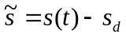. The most simple term to reduce the magnitude of the error uses the sign function as shown in Equation (6). Figures 10 and 11 show the phase portrait and time response, respectively when the switching control law is applied. k_{s} was chosen so, when on, the braking torque is strong enough.

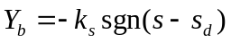
(6)

Switching control using the binary sign function inherently causes chattering seen in the figures. Especially notable are the sharp changes in desired torque values which might be problematic if the actuator is sensitive to high frequency inputs. Most likely, the hydraulic braking system will not physically be capable of high torque amplitudes at high frequency. This chattering effect is exactly that felt as the vibrations of a car being stopped quickly enough to engage the the anti-lock brake system.

Sliding Control

To reduce or eliminate the chattering, a sliding control law may be used instead of the switching control. This is accomplished by replacing the sign function with something less discontinuous such as a saturation function or a sigmoid function. The result of applying sliding control will smooth the braking, but may not brake faster than the switching control. See Equation 7 and Figures 12 and 13. Keep the same gain as the switching control law. Choose φ small such that the state remains close to s_{d}. Notice sliding control performs almost as well as switching control without the chatter.

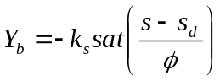
(7)

Robust Control

In attaining the maximum braking force, the most uncertainty in a real system comes from the unknown condition of the road surface. Whether the surface is dry, wet, icy, or otherwise, the exact relationship between the tire slip and the coefficient of friction is not known. One way to account for the uncertainty is to add an unknown parameter, θ, to scale the value of and have an adjustment for the controller to account for innacurate estimation of the dynamics. This was not implemented in part because the methods (I know about) to do so hinge upon the first-order dynamics of the sliding parameter and state variable errors which are not used in this model. Here, the desired conditions are dictated by the first derivatives of the state variables rather than the state variables themselves. It is sufficient to say the gain on the switching control’s sign function can be modified to adjust for the uncertatinty in the system and this gain may be time-varying to increase performance.

I attempted to implement both switching control and adaptive control despite the differences with no success.

Conclusion
Rigorous modeling of a braking system has been recreated here. A desired operational condition has been established and control laws implemented to attain to a desired performance. The physical manifestation of some of the mathematical results have been identified. This treatment showed the cause behind chattering in anti-lock brake systems. While tracking to a desired trajectory in first-order s-dynamics, the stability of the system is maintained insofar as it avoids wheel lock-up. The unknown condition of the road surface is identified as the most significant source of uncertainty and a means of compensating for this uncertainty is touched upon. Future work includes implementing the robust switching controller as well as an adaptive controller. An interesting study would be to determine if the adaptive controller is able to adapt quickly enough to be effective in this fast-transient scenario. I expect the simplicity, speed of reaction, and performance of the switching controller are desirable to the point where any danger to the operation of the braking system may be compensated for by structural design.

References

¹Olson, B. J., S. W. Shaw, and G. Stépán. "Nonlinear dynamics of vehicle traction." Vehicle System Dynamics 40.6 (2003): 377-399.
²Adcox, John. "Adaptive and Robust Braking-Traction Control Systems." Ph.D. Dissertation, Automotive Engineering Dept., Clemson Univ., (2014).
³Slotine, J.E., and Weiping, Li, Applied Nonlinear Control, Prentice Hall, Englewood Cliffs, NJ, 1991.

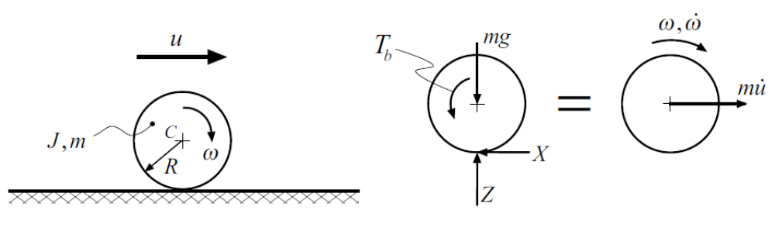
Figure 1 - System Diagram (a) and FBD = MAD (b)

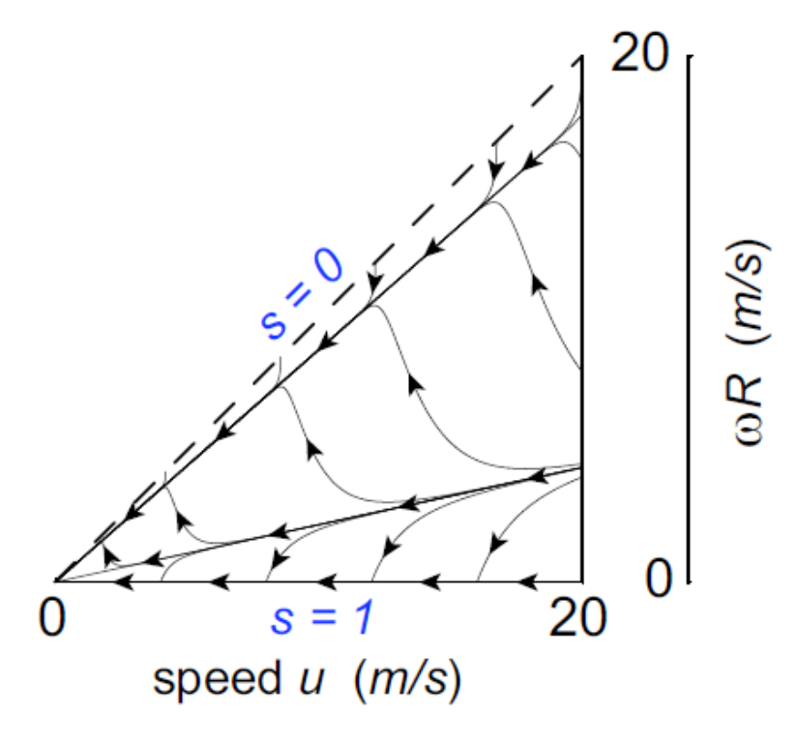
Figure 2 - Sample Phase Portrait

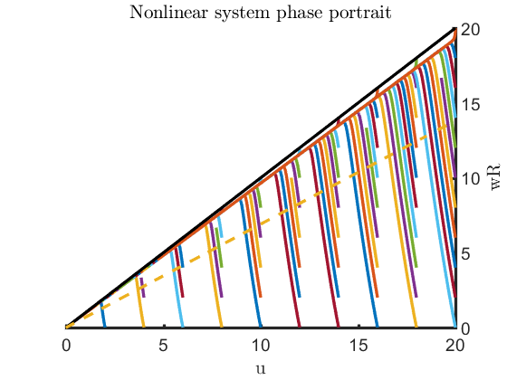
Figure 3 - nu = 15 Y_b = 5

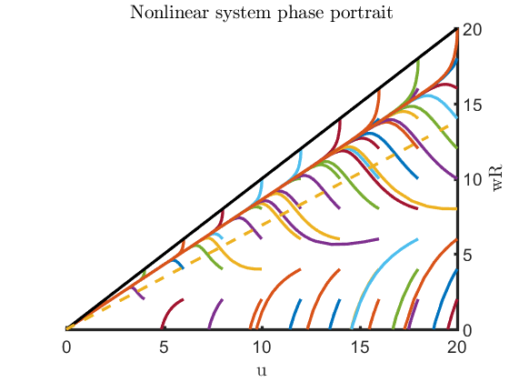
Figure 4 - Nu = 15 Y_b = 12

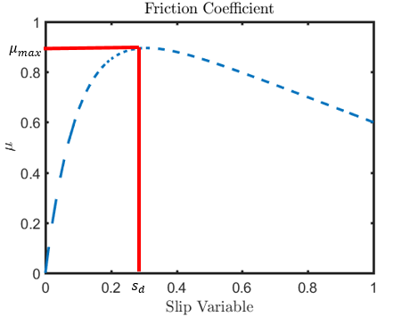
Figure 5 - Friction Coefficient and Maximum Value

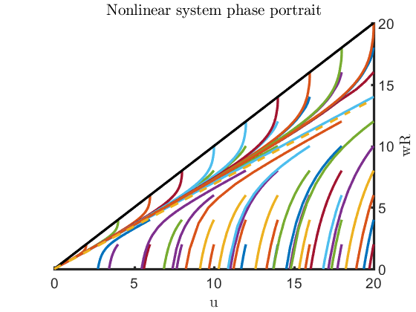
Figure 6 – Phase Portrait Optimal Torque

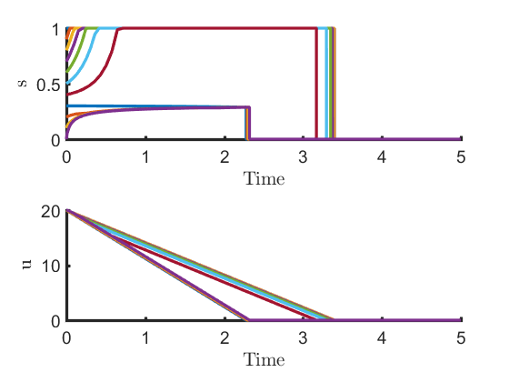
Figure 7 - Time Response Optimal Torque
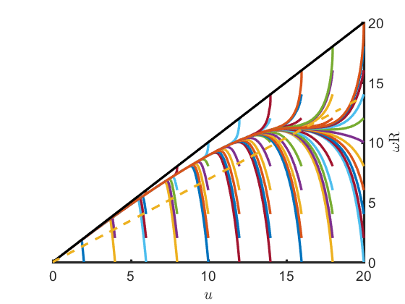
Figure 8 - Proportional Feedback Kp = 1.2
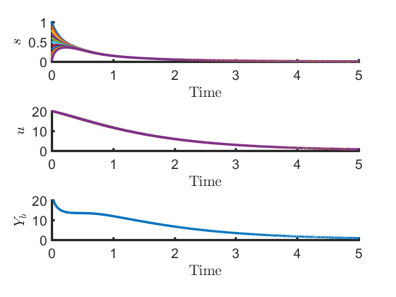
Figure 9 - Proportional Feedback Kp = 1.2
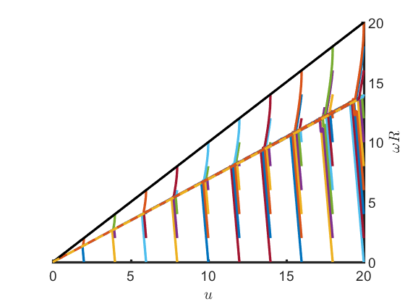
Figure 10 - Switching Control Portrait

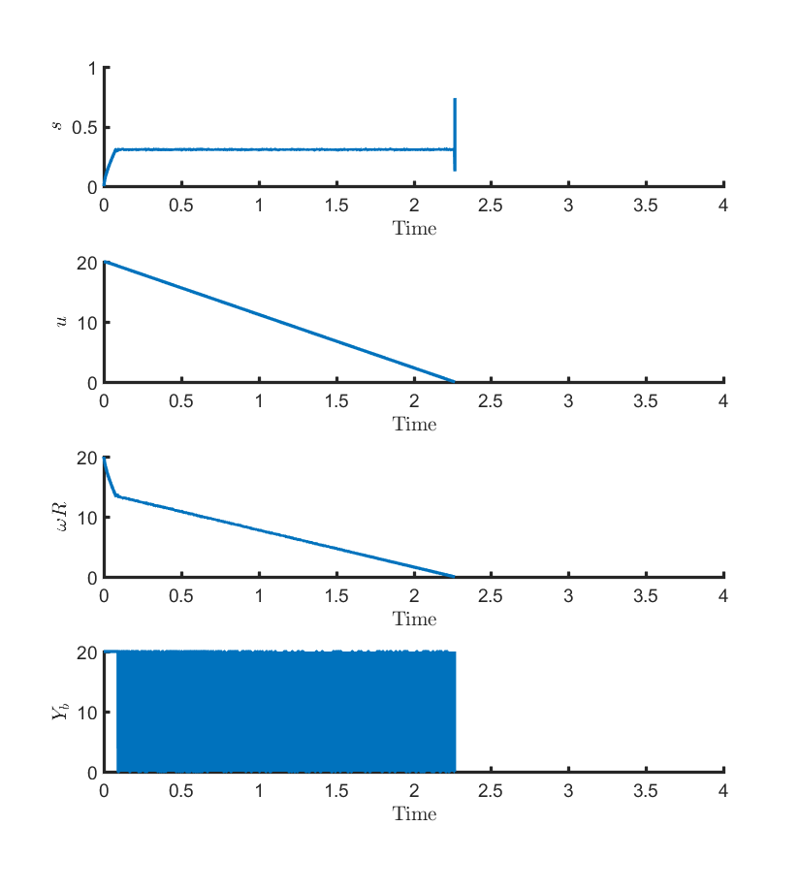
Figure 11 - Switching Control Time Response

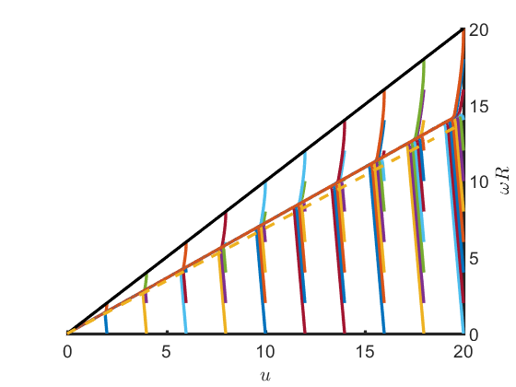
Figure 12 - Sliding Control Portrait

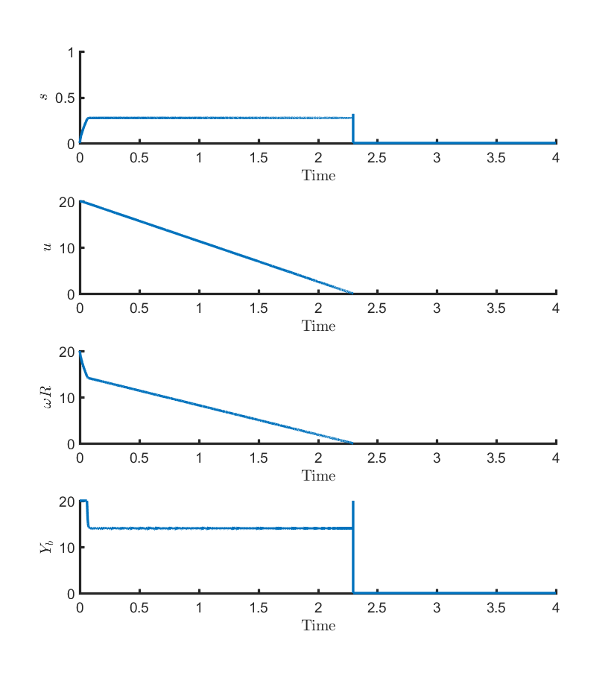
Figure 13 - Sliding Control Time Response

PhD Student, Mechanical and Aerospace Engineering.

